Steps for launching an EC2 Instance

Before launching an EC2 instance we should already have an account with Amazon Web Services.

Amazon Elastic Compute Cloud (Amazon EC2) is a web service that enables to launch and manage LINUX/UNIX and Windows Server Instances in Amazon’s data centres.

Step1: Sign into AWS account.

In AWS management console page the current region is displayed in the navigation bar at the top of the screen. This choice is important because some Amazon EC2 resources can be shared between regions, while others can't. Select the region that meets our needs.

Then click on EC2 tab.

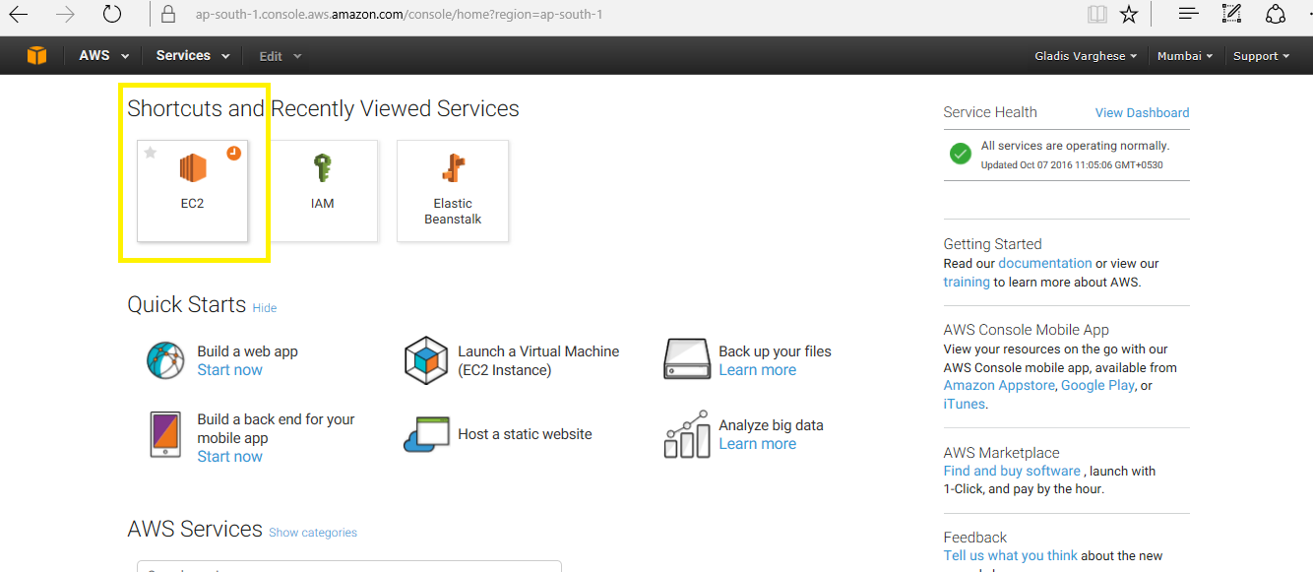

Step2: From the Amazon EC2 console dashboard, click on Launch instance.

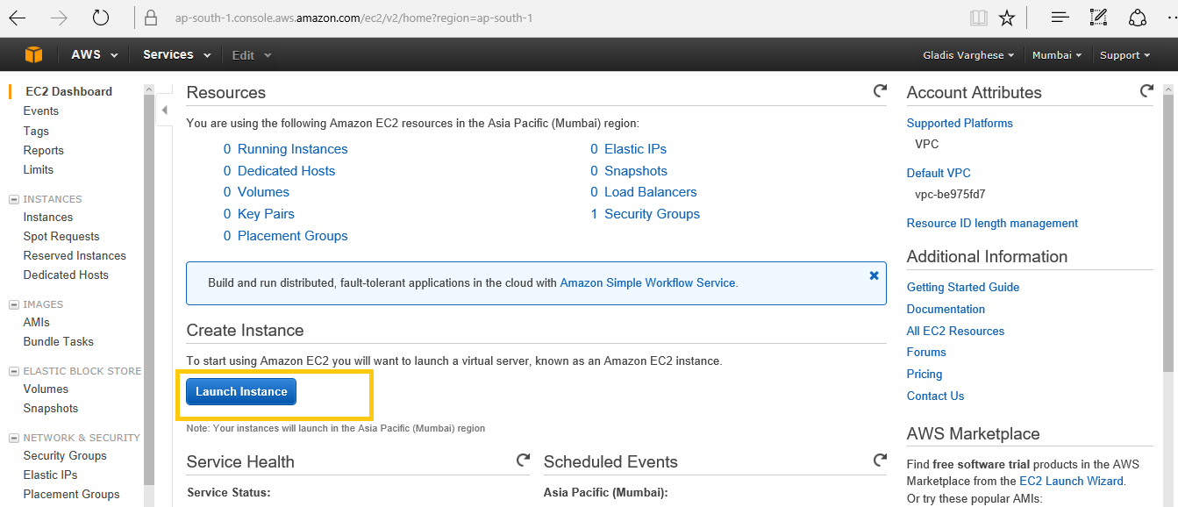

Step3: Choose an Amazon Machine Image (AMI)

An AMI contains the information required to create a new instance. For example, an AMI might contain the software required to act as a web server: for example, Linux, Apache, and your web site. To ensure that we select an AMI that is eligible for the free tier, choose Free tier only in the left pane.

On the Choose an Amazon Machine Image (AMI) page, choose an AMI as follows:

1. Select the type of AMI to use in the left pane

Quick Start (can choose Free tier only)

My AMIs

AWS Marketplace

Community AMIs

1. Check the Root device type listed for each AMI.

Either EBS or instance-store

1. Check the Virtualization type listed for each AMI.
2. Choose an AMI that meets your needs, and then choose Select

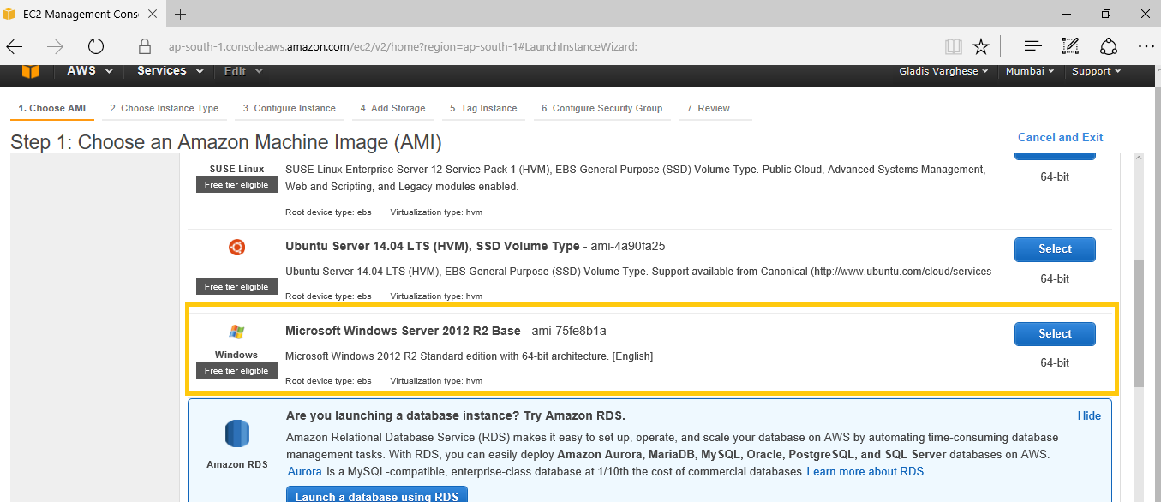

Step4: On the Choose an Instance Type page, select the hardware configuration and size of the instance to launch.

By default, the wizard displays current generation instance types, and selects the first available instance type based on the AMI that you selected. To view previous generation instance types, choose All generations from the filter list.

Choose Next: Configure Instance Details.

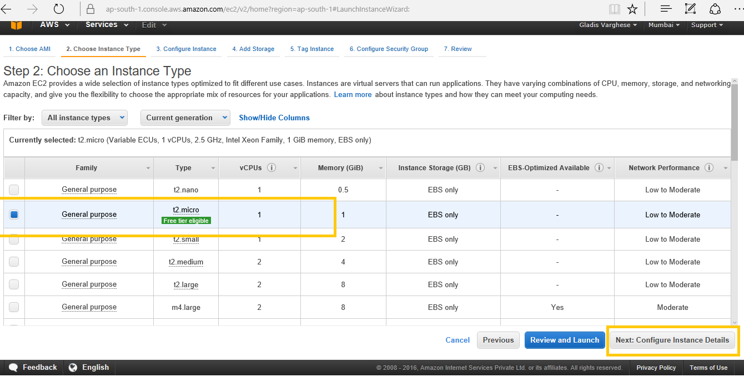

Step5: On the Configure Instance Details page, change the following settings as necessary and then choose next: Add Storage.

Select No preference to let AWS choose a default subnet in any Availability Zone.

Auto-assign Public IP Enable

Enable termination protection: Select this check box to prevent accidental termination.

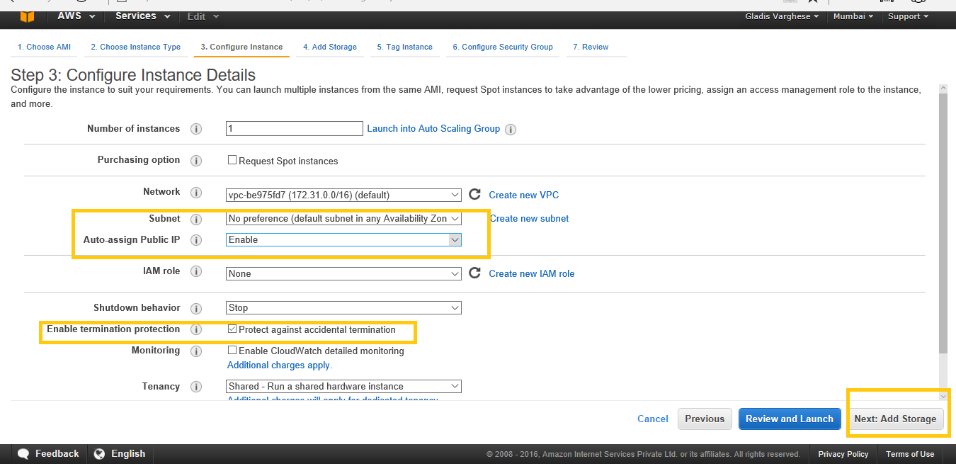

Step6: On the Add Storage page, we can specify volumes to attach to the instance besides the volumes specified by the AMI. Then choose next: Tag Instance when finished.

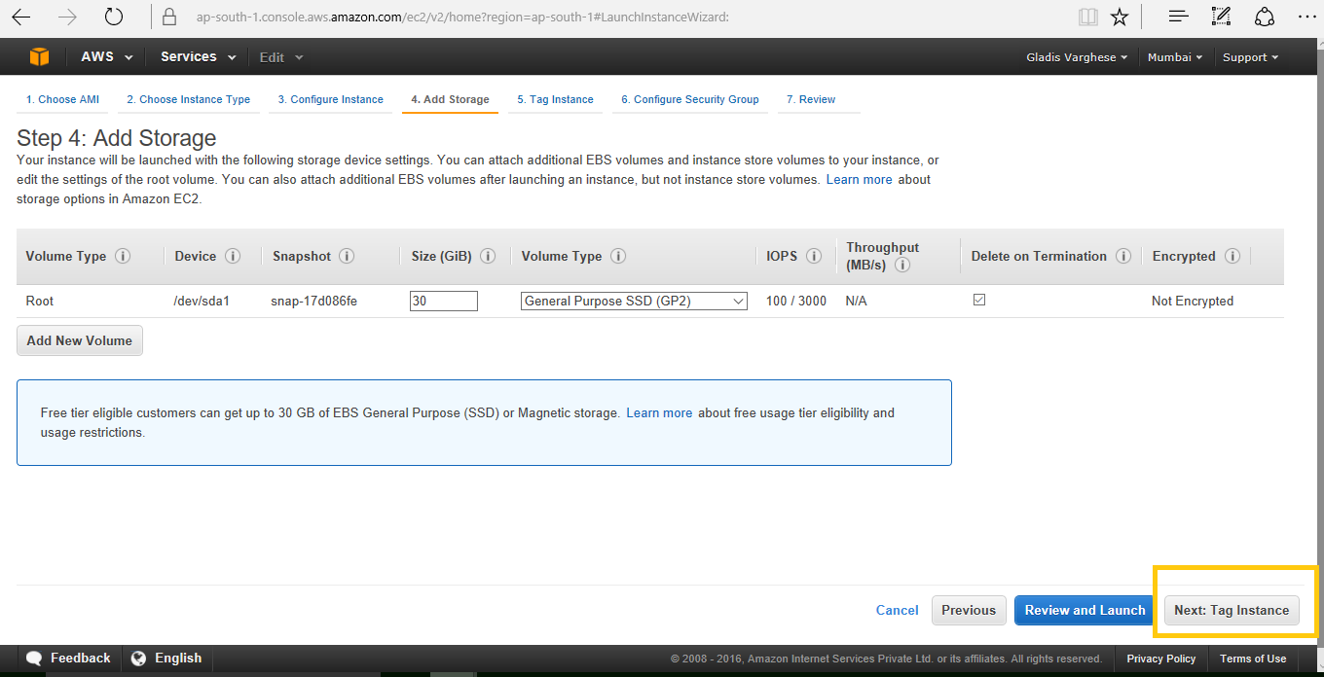

Step7: On the Tag Instance page, specify [tags](http://docs.aws.amazon.com/AWSEC2/latest/UserGuide/Using_Tags.html) for the instance by providing key and value combinations. Choose Create Tag to add more than one tag to our resource. Here ‘windows’ is given as key and ‘test-instance’ its value. Choose Next: Configure Security Group when you are done.

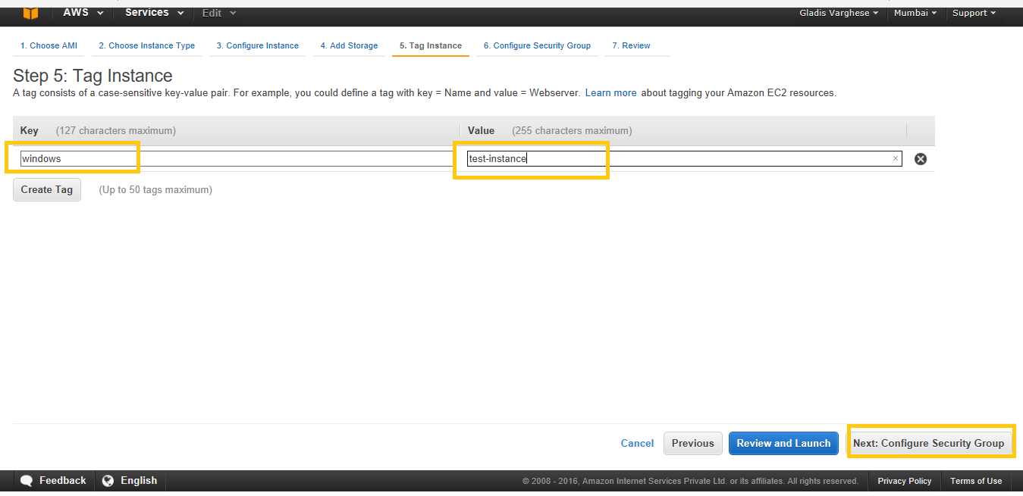

Step8: On the Configure Security Group page, use a security group to define firewall rules for your instance.

We can either select an existing security group or create a new one. Here select an existing security group and then choose Review and Launch. This security group enables all IP addresses to access the instance over the specified ports. This is acceptable for this short exercise, but it’s unsafe for production. In production we will authorize only a specific IP address or range of addresses to access the instance.

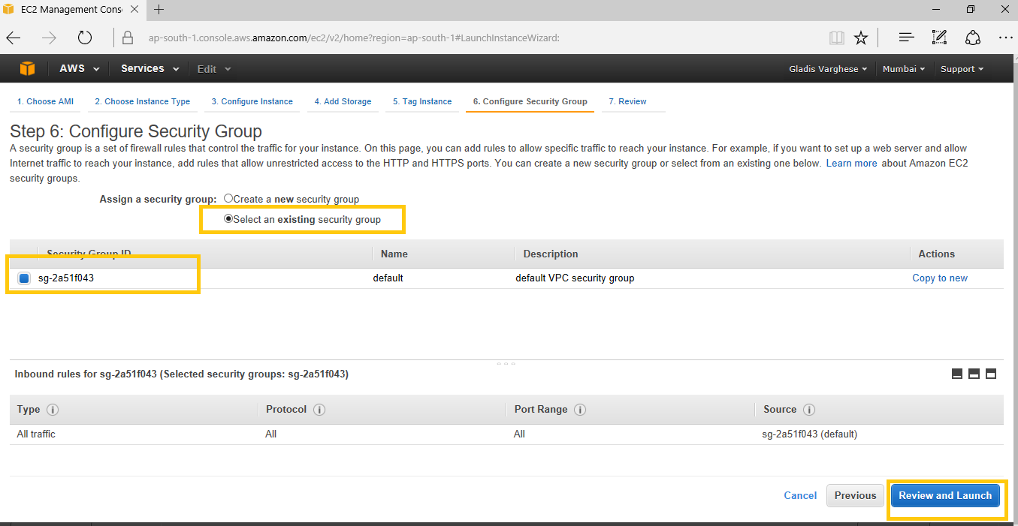

Step9: On the Review Instance Launch page, check the details of the instance, and make any necessary changes by choosing the appropriate Edit link. Then, choose Launch.

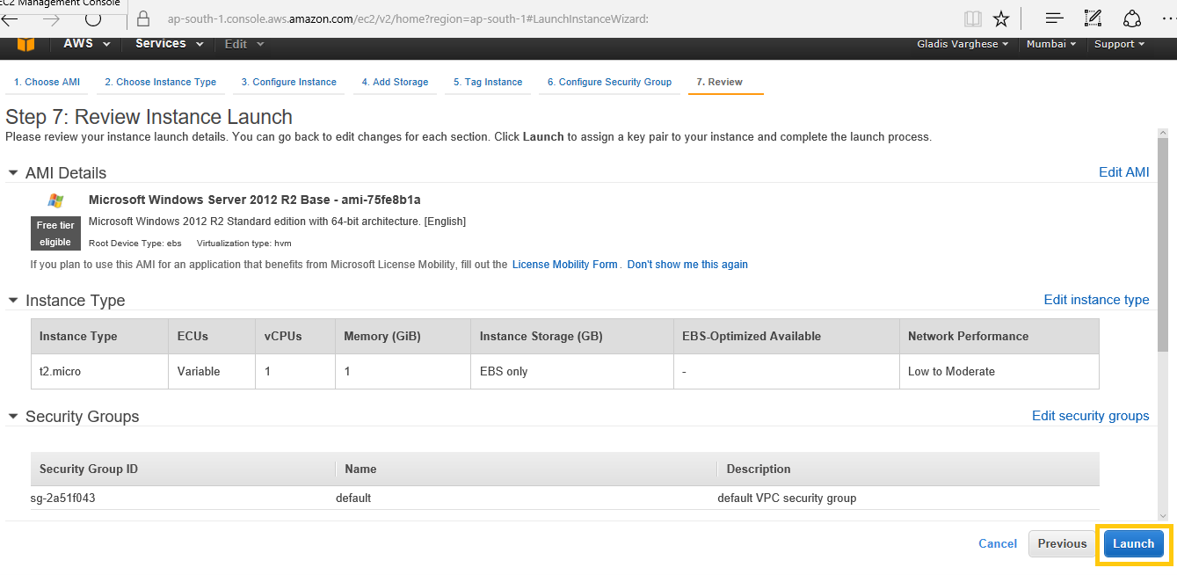

Step10: In the **Select an existing key pair or create a new key pair** dialog box, we can choose an existing key pair, or create a new one.

A Key pair is a security credential similar to password which we use to secure the connecting instance after its running. Here we are creating a new key pair. Enter a Key pair name and click on Download Key Pair. If we choose the Proceed without key pair option, we won't be able to connect to the instance unless you choose an AMI that is configured to allow users another way to log in.

Here we create a new Key Pair with name WindowsKP and click on Download Key Pair. Download and store private key file (*.pem file) in a secure and accessible location.

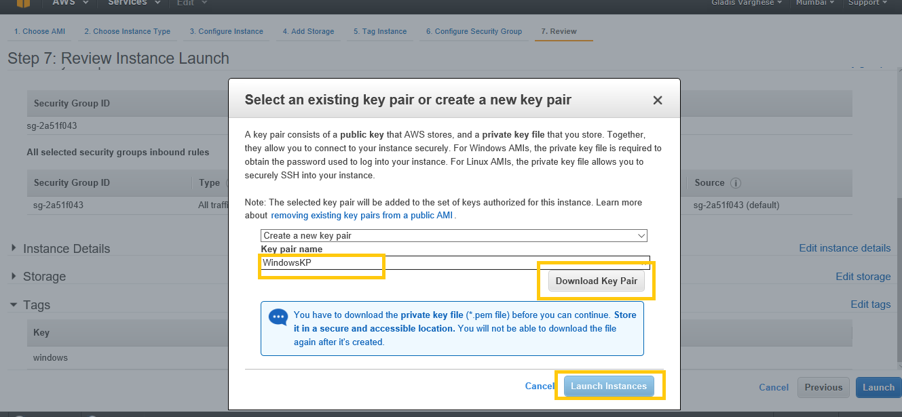

Step11: Click on View instances page. See the instance launched in running state.

Before going to instances page, (Optional) We can create a status check alarm for the instance (additional fees may apply).

